IZHAN SHEIKH

FRONT-END DEVELOPER

### UI/UX DESGINER

SEO

# PROFILE

I am a Class 10 student at The Smart School, currently pursuing a 3- year diploma in Software Engineering at Aptech. I am passionate about technology and specialize in front-end development, SEO, and UI/UX design. With a solid command of HTML, CSS, JavaScript, and proficiency in MS Office, I am focused on creating efficient, visually appealing, and user-friendly web solutions. By combining my academic pursuits with professional training, I aim to continually refine my skills and deliver innovative digital experiences.

# CONTACT

+92 334 9106777

Izhan SHEIKH [mizhansheikh5@gmail.com](mailto:mizhansheikh5@gmail.com) Izhan Sheikh

# Projects SKILLS

## Portfolio Website.

Created a personal portfolio website using HTML, CSS, and JavaScript to showcase my skills and projects.

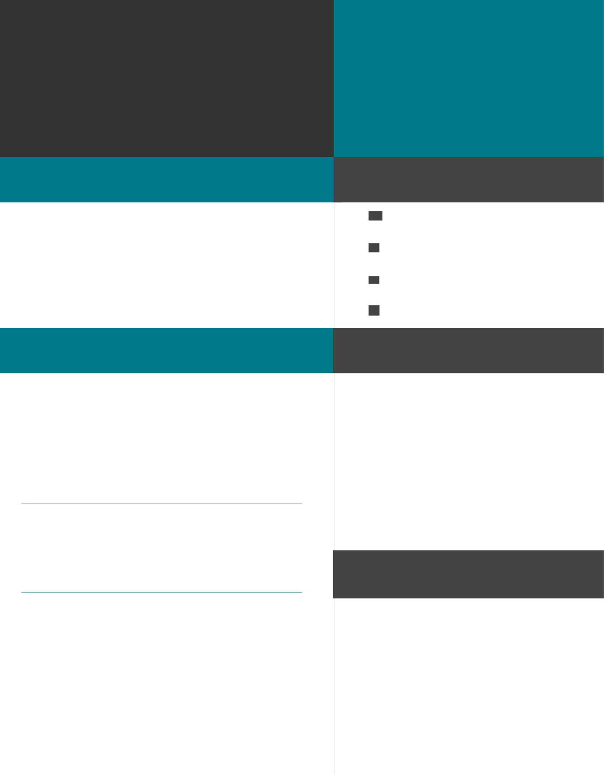

#### Key Features:

Includes a dynamic "About Me" section, skills showcase, and project gallery. Integrated smooth scrolling and interactive navigation for better user experience.

Outcome: Demonstrated proficiency in front-end development; showcased on GitHub and shared with potential employers.

## Nobel Prize Winners Website.

Created an informative website displaying biographies of Nobel Prize winners in science. Used HTML and CSS to ensure an engaging and responsive design.

O**utcome:** Demonstrated ability to design clean and organized websites with focus on user experience.

## UI/UX Design for Mobile App.

Designed a mobile app layout for a fictional food delivery service using Figma.

#### Key Features:

Created wireframes and prototypes showcasing user flow. Focused on color schemes, typography, and layout for a modern, minimalistic design.

#### Outcome:

Enhanced understanding of UI/UX principles and user-centered design.

* Front-End Developer
* SEO
* UI/UX design
* MS Office: Word, Excel, PowerPoint

# EDUCATION

### Smart School

2013-2025

Matriculation

### APTECH

2024-CURRENTY

Diploma Of Software Engineering